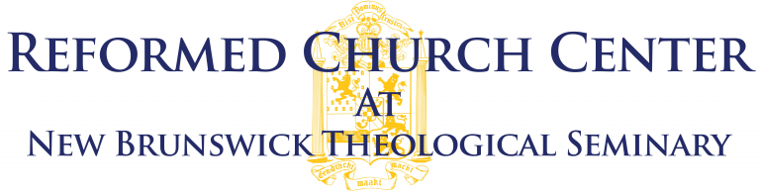

Application for the Alvin J. Poppen & John R. Young Fellowship
Please return to James Hart Brumm, Director of the Reformed Church Center, at 35 Seminary Place, New Brunswick, NJ 08901, or jbrumm@nbts.edu. The annual deadline is April 21st for the following academic year.

Applicant Information
Full Name:
 | Last | First | Middle

Address:
 | Street Address | Apartment/Unit #

 | City | State | ZIP Code

Phone: |  | Email:

Curriculum Vitae

Copy and paste applicant’s CV here.

The Nature of Your Project

Please explain the nature of your project in a paragraph or two. What topic are you investigating? What sources are you using? What questions are you raising and why?

The Significance of Your Project

Why is the project significant? How do you imagine that your project will be useful?

The Status of Your Project

Please describe, in a paragraph, the present state of your project. What have you done so far toward completing it? Please attach a bibliography of work you have published so far in the course of developing your project

The Goal of Your Project

What remains to be done? What final form do you expect the project to take? When do you hope to finish it?

How Can the Reformed Church Center help?

Please explain, in a paragraph, what resources you would hope to make use of at New Brunswick (as specifically as possible), and in general how you hope the Fellowship might help you accomplish the goal of completing your project.

When this form is complete,please return to jbrumm@nbts.edu.

